Short id for generat the list:

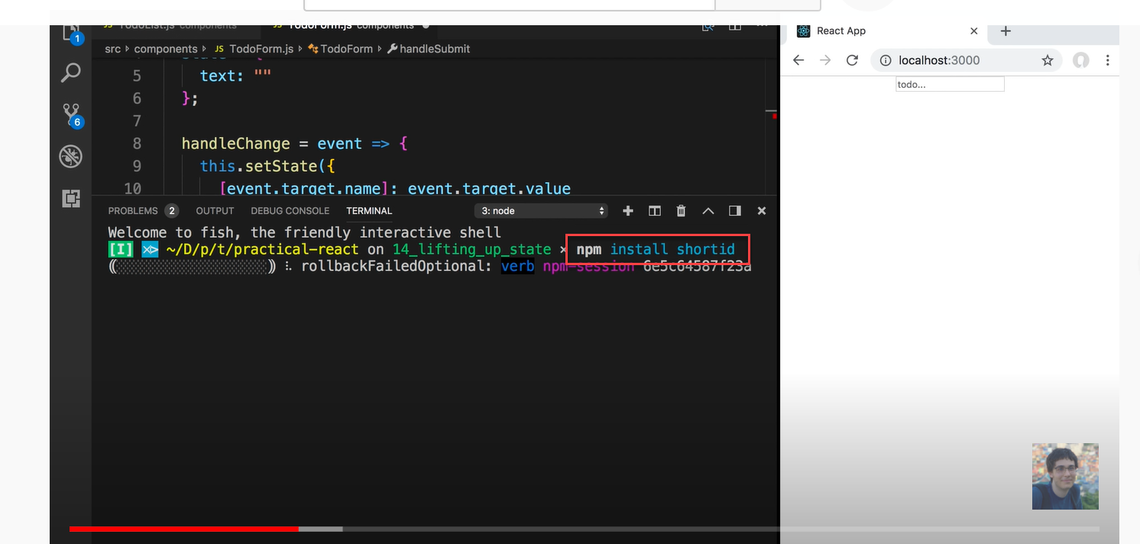

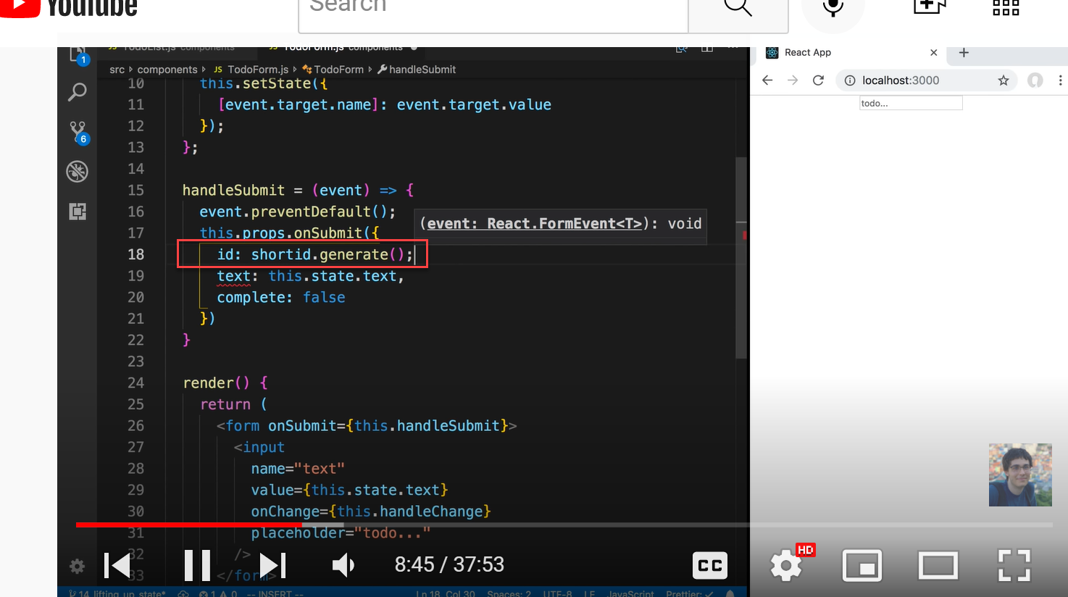

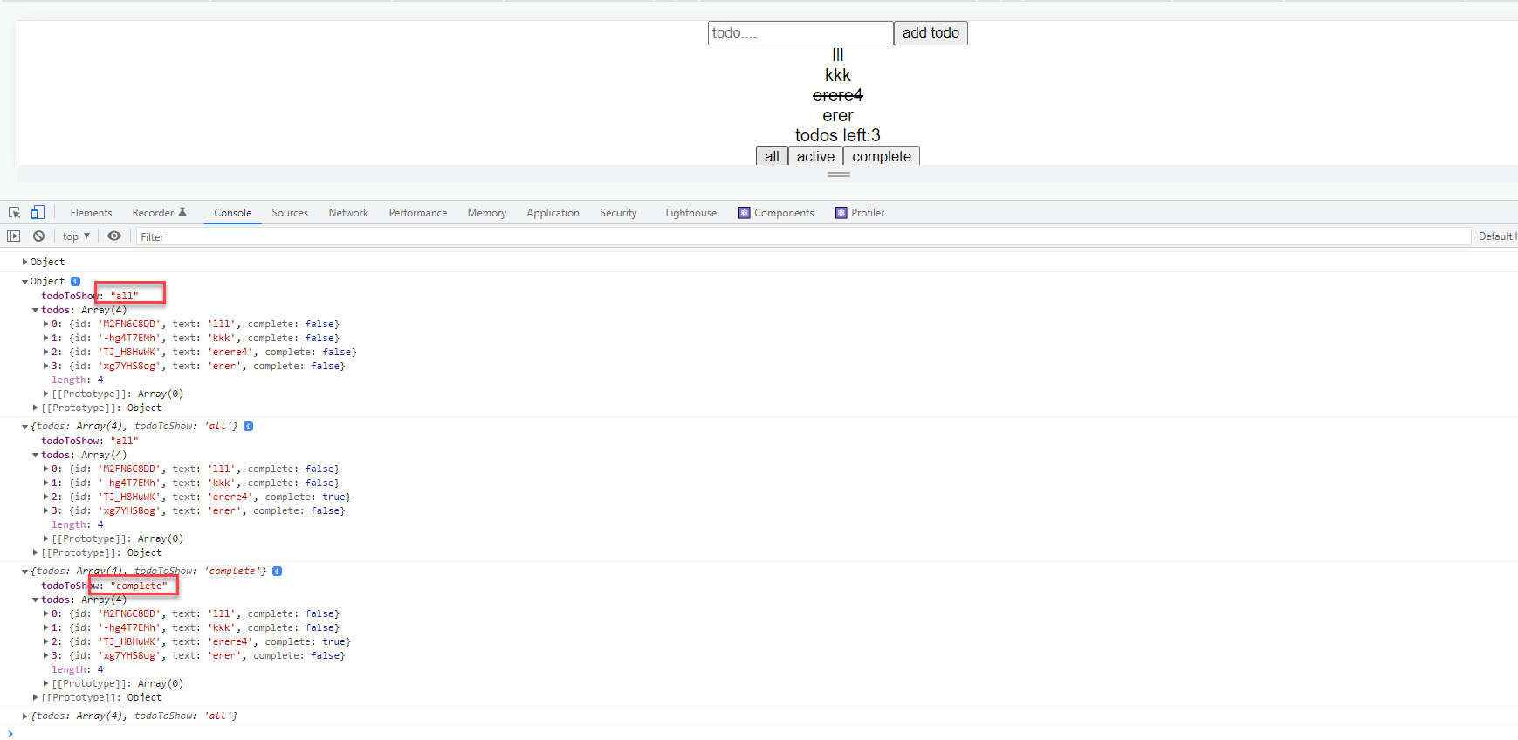

ObjecttodoToShow: "all"todos: Array(4)0: {id: 'M2FN6C8DD', text: 'lll', complete: false}1: {id: '-hg4T7EMh', text: 'kkk', complete: false}2: {id: 'TJ_H8HuWK', text: 'erere4', complete: false}3: {id: 'xg7YHS8og', text: 'erer', complete: false}length: 4[[Prototype]]: Array(0)[[Prototype]]: Object

TodoList.js:52 {todos: Array(4), todoToShow: 'all'}todoToShow: "all"todos: Array(4)0: {id: 'M2FN6C8DD', text: 'lll', complete: false}1: {id: '-hg4T7EMh', text: 'kkk', complete: false}2: {id: 'TJ_H8HuWK', text: 'erere4', complete: true}3: {id: 'xg7YHS8og', text: 'erer', complete: false}length: 4[[Prototype]]: Array(0)[[Prototype]]: Object

TodoList.js:52 {todos: Array(4), todoToShow: 'complete'}todoToShow: "complete"todos: Array(4)0: {id: 'M2FN6C8DD', text: 'lll', complete: false}1: {id: '-hg4T7EMh', text: 'kkk', complete: false}2: {id: 'TJ_H8HuWK', text: 'erere4', complete: true}3: {id: 'xg7YHS8og', text: 'erer', complete: false}length: 4[[Prototype]]: Array(0)[[Prototype]]: Object